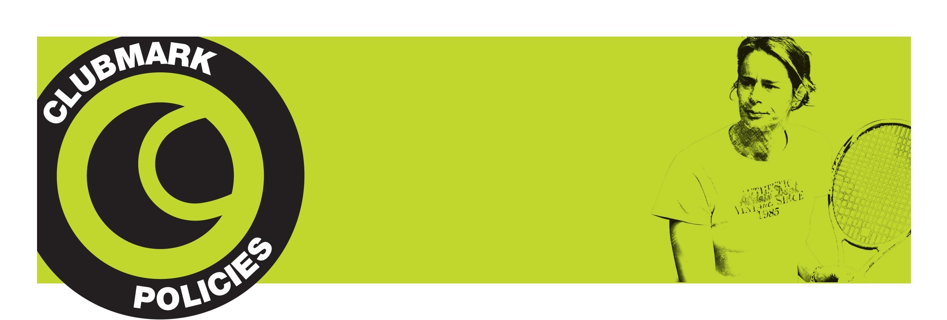
Child Protection
Policy

Child Protection Policy

Return Tennis will adhere to the following:

- aims to create an enjoyable environment for all juniors who wish to take part in tennis or other sport and social activities

- believe that children and young people have the right to be safe, secure and free from threat

- believe that young people have the right to be treated with respect, and to have their concerns listened to and acted upon

- ensure that the needs of junior members are provided for through specific programmes, designated facilities, and safe practice

- have procedures in place to address poor practice, and to help any young person who appears to be at risk, or who appears to be the victim of abuse

- offer help and support when a child or young person tells us that they are affected by these issues

- take steps to ensure that any volunteers or professionals working with children are suitable to do so, through the use of references and background checks

- ensure that all relevant people have been vetted and approved through the LTA’s Criminal Record Bureau disclosure process

- ensure that all of those working with children are made aware of the LTA code of conduct for people working with children in tennis, and are required to follow it

Any issues please contact Matt Marlow on 07835705286. Equally you can contact the LTA Child Protection team on the details below.

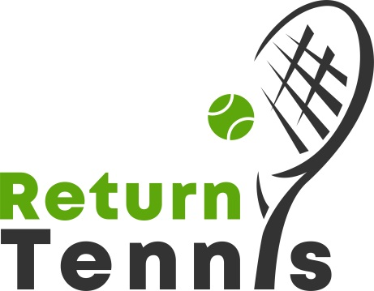

LTA Child Protection
T: 0208 487 7008/7116
M (24 hour): 07971 141 024
E: childprotection@lta.org.uk
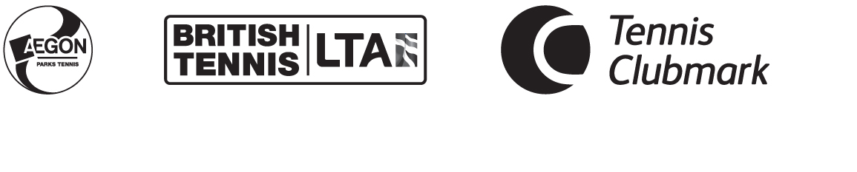
www.LTA.org.uk/childprotection

